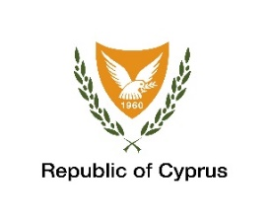

**JUDICIAL PRESS OFFICE OF THE SUPREME COURT**

_________________________________________________________

**PRESS RELEASE**

Nicosia, 14 September 2020

**PRESENTATION OF THE GUIDE TO JUDICIAL CONDUCT**

With the commencement of the new judicial year and on the occasion of the fourth revision to the Guide to Judicial Conduct, the Supreme Court deems it beneficial to present the revised Guide to Judicial Conduct to the first instance Judges of Cyprus, who in the meantime, have been asked to express their views and suggestions on any future amendments to the Guide with a view to aid its improvement.

Due to the prevailing Covid-19 conditions, the presentation will be conducted via teleconference, on Thursday 24th of September 2020.

An in-depth presentation of the Guide will be conducted by Ms Lena Demetriadou, Administrative President of the Nicosia District Court, preceded by the opening speech of the President of the Supreme Court Mr Stelios Nathanael and the welcome address of the President of the Cyprus Judges Association Mr Nicolaos Santi, District Court President.

Meanwhile, under the responsibility of the Judicial Training School of the Supreme Court, a training seminar on ‘Judicial Deontology and Ethics’ has been scheduled to take place on the 6th of October 2020 with the participation of all newly-appointed Judges. The seminar will be conducted by three trained Judges (Presidents of the District Court) (Ms Lena Demetriadou, Mr Aggelos David and Ms Marina Papadopoulou).

Moreover, the Guide to Judicial Conduct has been posted on the website of the Supreme Court in Greek as well as in English.

Lastly, the Guide to Judicial Conduct will soon be made available by the Supreme Court in the form of booklets.